Using treated wastewater for hydroponic cultivation of vegetables in the Antarctic

Using treated wastewater for hydroponic cultivation of vegetables in the Antarctic

**An Information Paper submitted by Portugal and Bulgaria**

***Summary***

Here we describe the development of a process for treatment of wastewater for the production of a nutrient solution for use in Antarctic hydroponic systems.

***Introduction***

The Protocol on Environmental Protection to the Antarctic Treaty states that activities in the Antarctic Treaty Area shall be planned and conducted to limit adverse impacts on the Antarctic environment and dependent and associated ecosystems and to avoid significant adverse effects on air and water quality (Article3).Challenges in wastewater treatment in the Antarctic have been recognized, exacerbated by a lack of local technical expertise that would be available in most other areas in the World (ATCM XXV IP51, ATCM XXIX IP60, ATCM XXXVIII IP74). The CEP, Parties and the Council of Managers of National Antarctic Programs (COMNAP) have shared information on wastewater treatment, emphasized the need for monitoring in areas near sewage treatment plants and acknowledged the value of information sharing on environmental challenges and solutions (ATCM XXV IP51, ATCMXXXVIII IP74, ATCM XXXIX BP8, ATCM XL IP38).

Hydroponic cultivation systems have been considered an alternative biological technology for the reuse of wastewater and nutrient recovery without the environmental consequences of traditional cultivation methods (Prazeres et al., 2017). With the introduction of non-sterile soil to the Antarctic Treaty area prohibited under the Protocol, hydroponic cultivation systems have proven to be a viable alternative option for in-situ food production.  Here we report the development of a process whereby wastewater is treated by chemical precipitation for the subsequent production of hydroponic nutrient solutions. The process was tested at the Bulgarian Antarctic Base, Livingston Island, South Shetland Islands (Correia et al., 2020).

***Wastewater treatment system***

A recent study (see: Correia et al. (2020) has developed a low-cost process for wastewater treatment that produces nutrient solutions for hydroponic cultivation of fresh foods on Antarctic stations. The wastewater treatment system involved the manual addition and mixing of lime, to generate a high pH solution and kill pathogenic microorganisms. The pH of the nutrient solution is then reduced by bubbling through air (which contains atmospheric CO2) to make it suitable for plant cultivation.

Lime is widely available and inexpensive, the use of air to reduce the alkalinity the lime solution is a relatively simply process, and the manual agitation of the solution allows it to be performed where energy supply and specialized equipment are not readily available. The resulting nutrient solution had macronutrient values (nitrogen and phosphorous) below the values of commercially available nutrient solutions and pH of 8.0, but was still suitable for lettuce production. The treatment also removed all coliform bacteria, thereby reducing risks associated with pathogens (Correia et al., 2020).

Testing of the new system on the Bulgarian Antarctic Base using the nutrient solution generated from wastewater was successful and supported the growth of four lettuce plants during the 14 days that the system was fully operational in February 2019. The plants’ lengths increased by an average of 11%, the diameter by 50%, the number of leaves by 46%, and we observed a 62% increase in weight (Figure 1).

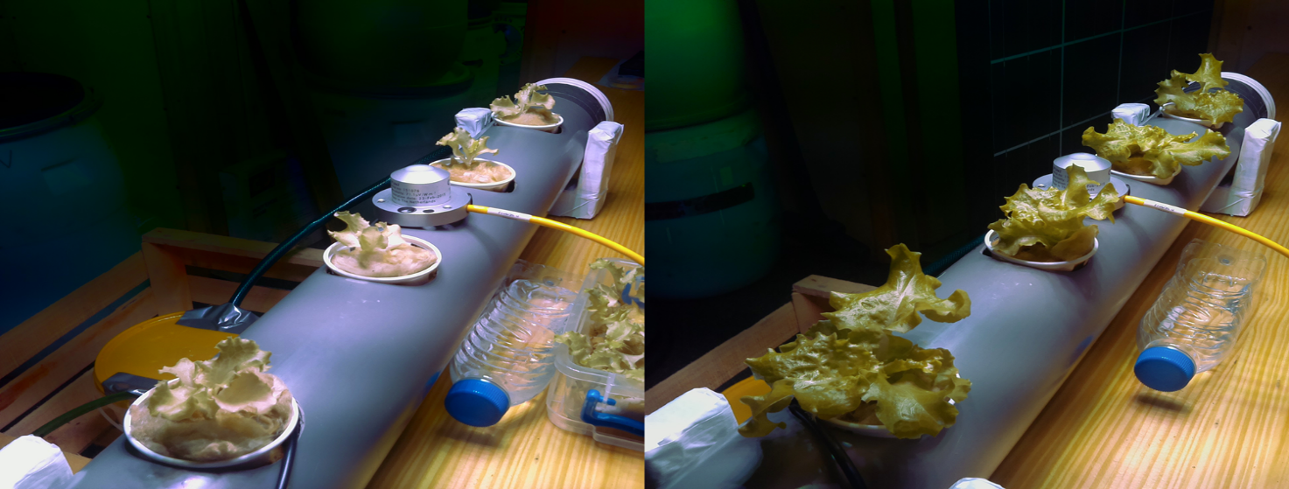

**A**

**B**

Figure 1. Lettuce plants aerial size on day 0 (A) and day 14 (B) of cultivation tests at the Bulgarian Antarctic Base.

The process described here had several benefits:

* It can reduce the quantity of wastewater released into the Antarctic environment.
* It is technically simple and is largely unaffected by temperature changes and variable input loads (Semerjian & Ayoub, 2003).
* Reusing treated wastewater as nutrient solution in hydroponic cultivation systems reduces the need for importation of commercial nutrient solutions thereby reducing the importation of chemicals and use of precious freshwater supplies.

In summary, this study has provided preliminary data which demonstrates that lime-treated and air neutralized wastewater can be successfully used to cultivate fresh foods. Following further exotoxicological and plant growth studies, the system could be scaled up for use in larger hydroponic cultivation facilities within Antarctica, or other remote locations.

***References***

Bamsey, M. T., Zabel, P., Zeidler, C., Gyimesi, D., Schubert, D., Kohlberg, E., Mengedoht, D., Rae, J., & Graham, T. (2015). Review of Antarctic Greenhouses and Plant Production Facilities : A Historical Account of Food Plants on the Ice. *45th International Conference on Environmental Systems*, *July*, 1–36.

Correia, T., Regato, M., Almeida, A., Santos, T., Amaral, L., & Carvalho, F. (2020). Manual treatment of urban wastewater by chemical precipitation for production of hydroponic nutrient solutions. *Journal of Ecological Engineering*, *21*(3), 143–152. https://doi.org/10.12911/22998993/118286

Prazeres, A. R., Albuquerque, A., Luz, S., Jerónimo, E., & Carvalho, F. (2017). Hydroponic System: A Promising Biotechnology for Food Production and Wastewater Treatment. In A. Grumezescu & A.-M. Holban (Eds.), *Food Biosynthesis* (1st ed., pp. 317–350). Elsevier. https://doi.org/10.1016/C2016-0-00180-8

Semerjian, L., & Ayoub, G. M. (2003). High-pH–magnesium coagulation–flocculation in wastewater treatment. *Advances in Environmental Research*, *7*(2), 389–403. https://doi.org/10.1016/S1093-0191(02)00009-6